Fatima Jinnah Women Univeristy


Project # 09

INFRASTRUCTURE MONITORING AND LOG COLLECTION SYSTEM

Course Title : Cloud Computing

Submitted by :
Lujain Zia (2023-BSE-034)
Alishba Zainab (2023-BSE-006)
Fatima Kashif (2023-BSE-018)

Submitted to :
Engr. Waqas Saleem

Date : January 27, 2026

Department of Software Engineering

Fatima Jinnah Women University

Table of Contents

- Executive Summary _ _ _ _ _ _ _ _ _ _ _ _ _ _ _ _ _ _ _ _ _ _ _ _ _ _ _ _ _ _ _ _ _ _ _ _ _ _ _ _ _ _ _ _ _ _ _ _ _ _ _ 3
- Part 1: Git Repository & Structure _ _ _ _ _ _ _ _ _ _ _ _ _ _ _ _ _ _ _ _ _ _ _ _ _ _ _ _ _ _ _ _ _ _ _ _ _ _ _ _ _ 3
1.1 Repository Structure _ _ _ _ _ _ _ _ _ _ _ _ _ _ _ _ _ _ _ _ _ _ _ _ _ _ _ _ _ _ _ _ _ _ _ _ _ _ _ __ _ 3
1.2 .gitignore Configuration _ _ _ _ _ _ _ _ _ _ _ _ _ _ _ _ _ _ _ _ _ _ _ _ _ _ _ _ _ _ _ _ _ _ _ _ _ _ _ _5
1.3 Branching Strategy_ _ _ _ _ _ _ _ _ _ _ _ _ _ _ _ _ _ _ _ _ _ _ _ _ _ _ _ _ _ _ _ _ _ _ _ _ _ _ _ _ _ _ 6
- Part 2: Terraform Infrastructure _ _ _ _ _ _ _ _ _ _ _ _ _ _ _ _ _ _ _ _ _ _ _ _ _ _ _ _ _ _ _ _ _ _ _ _ _ _ _ _ _ _ 7
2.1 Network Module - VPC & Subnets_ _ _ _ _ _ _ _ _ _ _ _ _ _ _ _ _ _ _ _ _ _ _ _ _ _ _ _ _ _ _ _ _ 7
2.2 Monitoring Server Module_ _ _ _ _ _ _ _ _ _ _ _ _ _ _ _ _ _ _ _ _ _ _ _ _ _ _ _ _ _ _ _ _ _ _ _ _ _ 9
2.3 Application Servers Module_ _ _ _ _ _ _ _ _ _ _ _ _ _ _ _ _ _ _ _ _ _ _ _ _ _ _ _ _ _ _ _ _ _ _ _ _11
- Part 3: Ansible Configuration _ _ _ _ _ _ _ _ _ _ _ _ _ _ _ _ _ _ _ _ _ _ _ _ _ _ _ _ _ _ _ _ _ _ _ _ _ _ _ _ _ _ _ _ 20
3.1 Configure Application Servers_ _ _ _ _ _ _ _ _ _ _ _ _ _ _ _ _ _ _ _ _ _ _ _ _ _ _ _ _ _ _ _ _ _ _ 20
3.2 Configure Monitoring Server_ _ _ _ _ _ _ _ _ _ _ _ _ _ _ _ _ _ _ _ _ _ _ _ _ _ _ _ _ _ _ _ _ _ _ _ 21
3.3 Log Collection Using Ansible_ _ _ _ _ _ _ _ _ _ _ _ _ _ _ _ _ _ _ _ _ _ _ _ _ _ _ _ _ _ _ _ _ _ _ _28
- Part 4: Dashboard & Reporting _ _ _ _ _ _ _ _ _ _ _ _ _ _ _ _ _ _ _ _ _ _ _ _ _ _ _ _ _ _ _ _ _ _ _ _ _ _ _ _ _ _ _29
4.1 Simple Web Dashboard_ _ _ _ _ _ _ _ _ _ _ _ _ _ _ _ _ _ _ _ _ _ _ _ _ _ _ _ _ _ _ _ _ _ _ _ _ _ _ _29
4.2 Automated Reporting_ _ _ _ _ _ _ _ _ _ _ _ _ _ _ _ _ _ _ _ _ _ _ _ _ _ _ _ _ _ _ _ _ _ _ _ _ _ _ _ _ 31
- Part 5: Documentation & Basic Runbooks _ _ _ _ _ _ _ _ _ _ _ _ _ _ _ _ _ _ _ _ _ _ _ _ _ _ _ _ _ _ _ _ _ _ _ 34
- GitHub Repository _ _ _ _ _ _ _ _ _ _ _ _ _ _ _ _ _ _ _ _ _ _ _ _ _ _ _ _ _ _ _ _ _ _ _ _ _ _ _ _ _ _ _ _ _ _ _ _ _ _ _ 37

Executive Summary
This document presents the complete implementation of Project 9: Infrastructure Monitoring and Log Collection System. The project demonstrates the practical application of cloud computing concepts, infrastructure automation, and system monitoring using industry-standard tools including Terraform, Ansible, and AWS services.
The system architecture consists of a centralized monitoring server that continuously monitors multiple application servers, collects logs, generates reports, and displays real-time status through a web-based dashboard. All infrastructure is provisioned using Terraform (Infrastructure as Code), configured using Ansible (Configuration Management), and monitored using custom Bash scripts.

Part 1: Git Repository & Structure

1.1 Repository Structure
The project follows a well-organized directory structure that separates concerns and facilitates maintainability. The repository is structured as follows:
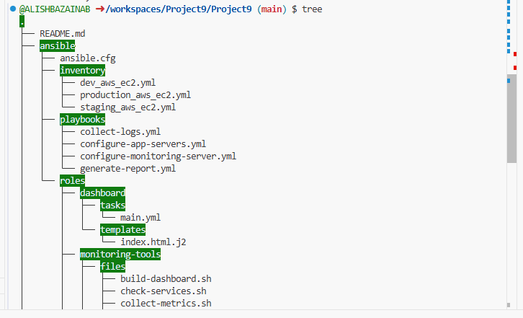
Figure 1.1: Project Repository Structure - Root Level
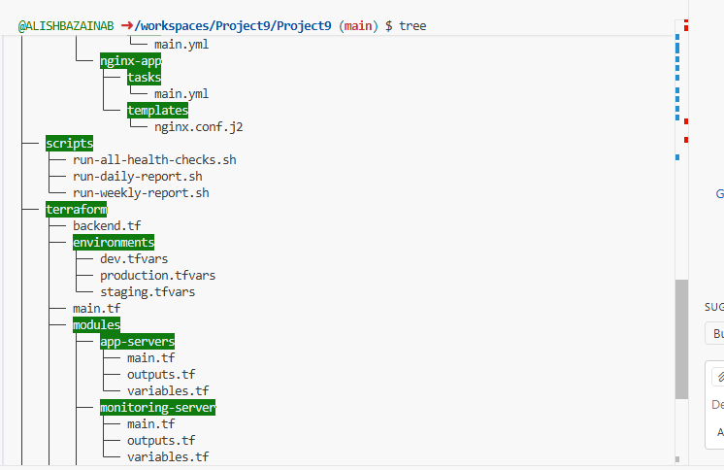
Figure 1.2: Project Repository Structure - Terraform Modules
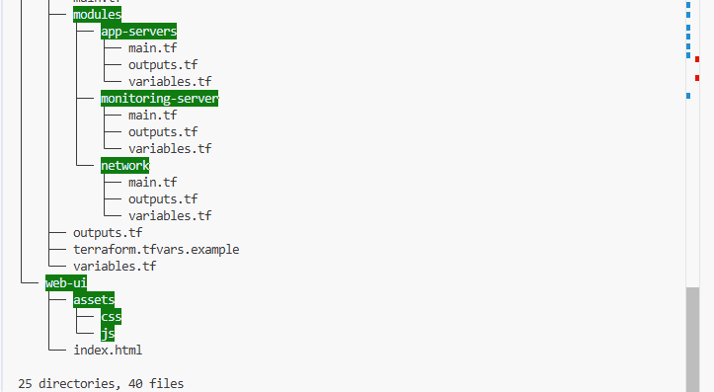
Figure 1.3: Project Repository Structure - Ansible Roles
The repository was initialized with Git and includes all necessary directories for Terraform modules, Ansible playbooks, roles, and monitoring scripts.

1.2 .gitignore Configuration
A comprehensive .gitignore file was created to exclude sensitive files, temporary files, and build artifacts from version control. This ensures that credentials, state files, and IDE-specific files are not accidentally committed to the repository.
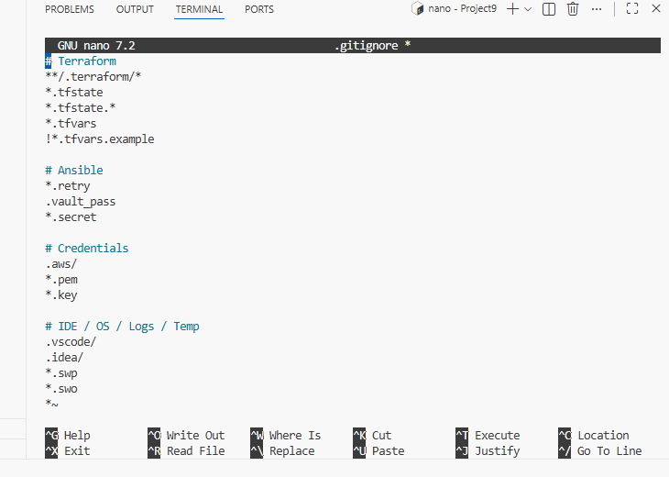
Figure 1.4: .gitignore File Configuration
The .gitignore includes exclusions for:
- Terraform state files and .terraform directories
- Ansible retry files and vault passwords
- AWS credentials and SSH keys
- IDE-specific files (.vscode, .idea)
- Temporary and log files
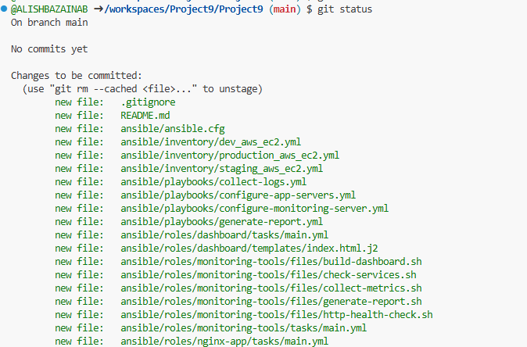
Figure 1.5: Git Status Showing Clean Working Directory
Git status was verified to ensure no sensitive files are being tracked in version control.

1.3 Branching Strategy
A simple yet effective branching strategy was implemented with main and dev branches. Feature branches are created from dev for experimental work, then merged back via pull requests.
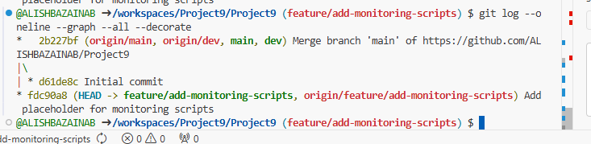
Figure 1.6: Git Branching Strategy
The branching model follows:
- main - Stable production-ready code
- dev - Active development branch
- feature/* - Feature-specific branches merged into dev

Part 2: Terraform Infrastructure

2.1 Network Module - VPC & Subnets
The network module creates the foundational AWS networking infrastructure including VPC, subnets etc. The architecture uses a public subnet for the monitoring server and private subnets for application servers.

Figure 2.1: Network Module
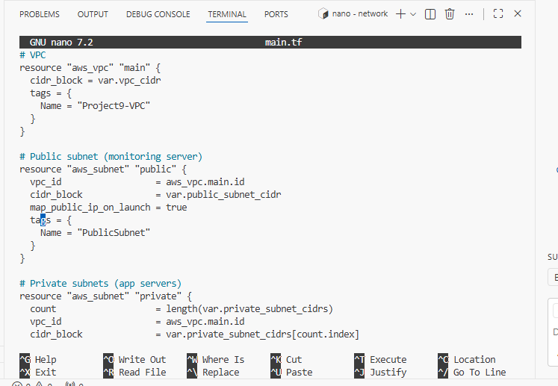
Figure 2.2: Network Module - VPC and Subnet Configuration

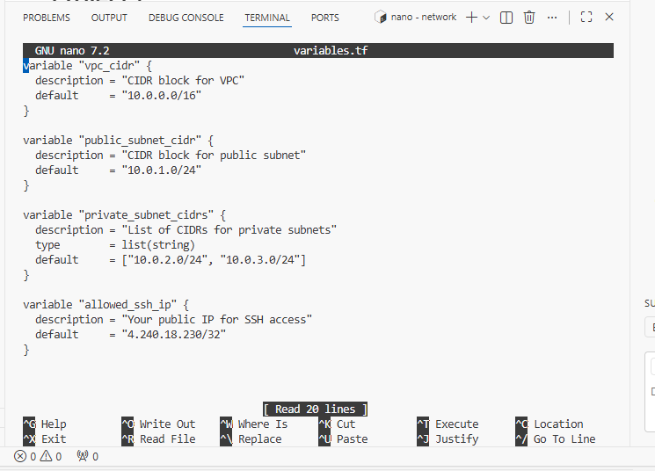
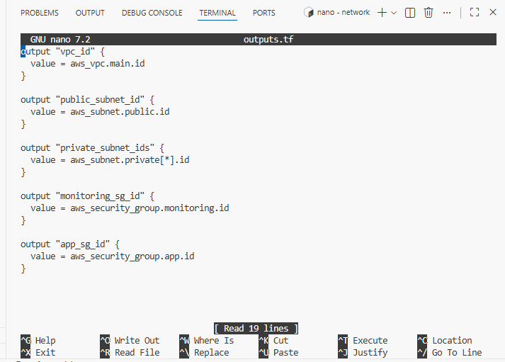
Figure 2.3: Network Module - Security Groups Configuration
The network module provisions:
- VPC with CIDR block 10.0.0.0/16
- Public subnet for monitoring server
- Private subnet for application servers
- Security groups for monitoring and application servers

2.2 Monitoring Server Module
The monitoring server module provisions an EC2 instance in the public subnet with appropriate security group rules to allow HTTP access for the dashboard and SSH access for administration.


Figure 2.4: Monitoring Server Module - EC2 Instance Configuration

Figure 2.5: Monitoring Server Module - Outputs and Variables
The monitoring server is configured with:
- Public IP address for dashboard access
- Security group allowing HTTP (port 80) and SSH (port 22)
- Appropriate instance type and AMI
- Role tag: monitoring

2.3 Terraform Root Configuration
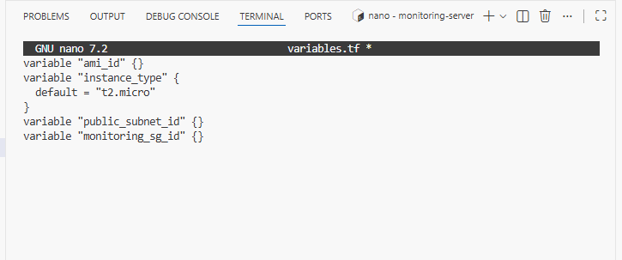
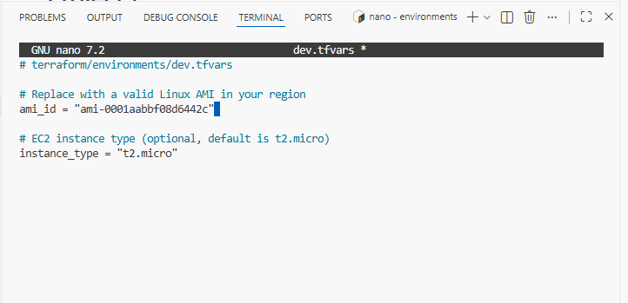
Figure 2.6: Root Terraform Configuration - Provider and Module Calls
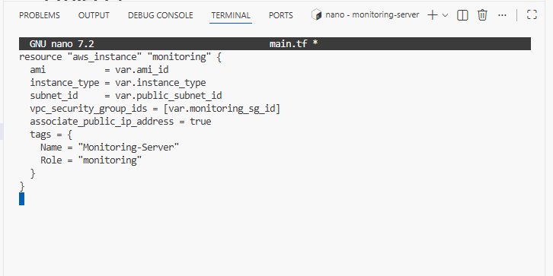
Figure 2.7: Root Terraform Configuration - Network Module
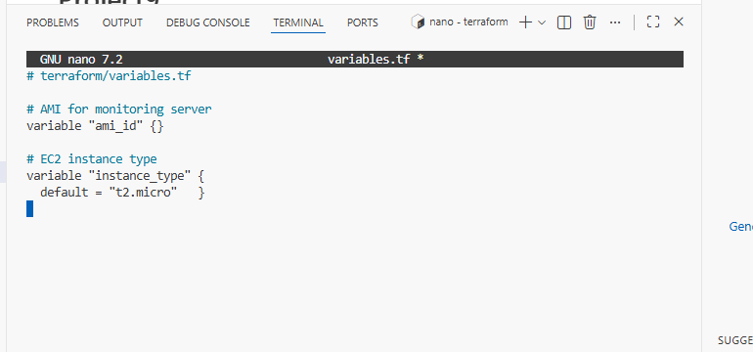
Figure 2.8: Root Terraform Configuration - Variables
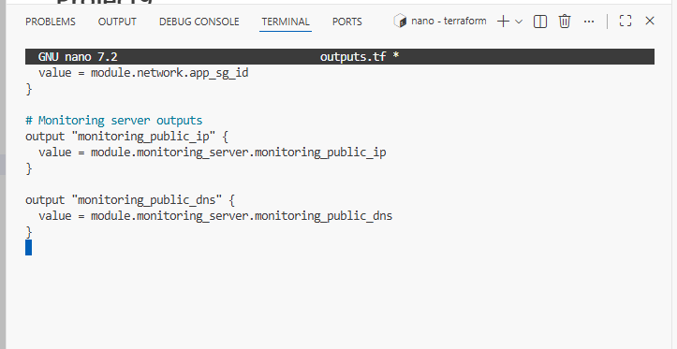
Figure 2.9: Root Terraform Configuration - Outputs

Terraform Initialization and Application
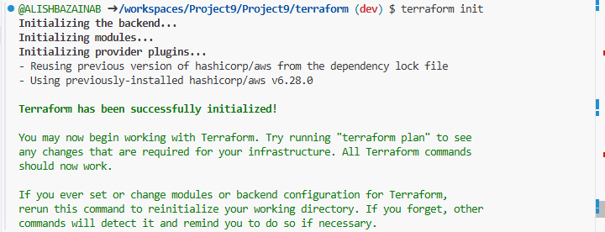Figure 2.10: Terraform Initialization Success
The infrastructure was initialized using terraform init, which downloaded required providers and initialized the backend.
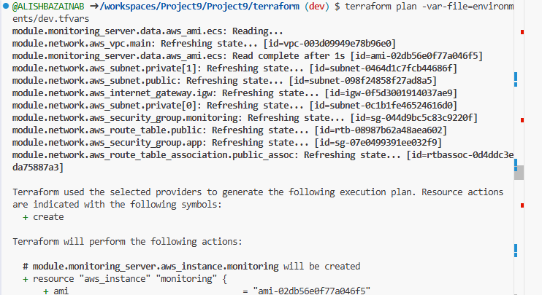Figure 2.11: Terraform Plan Output Showing Resources to be Created
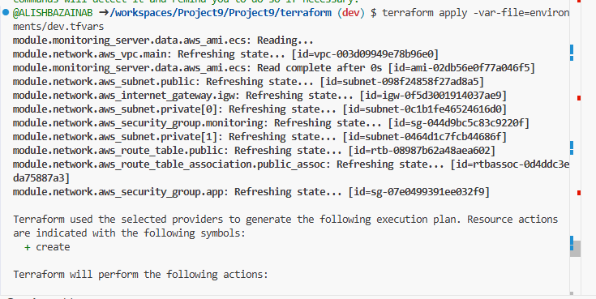Figure 2.12: Terraform Apply - Infrastructure Provisioning Success
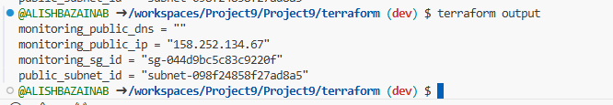Figure 2.13: Terraform Output Values - Monitoring Server IP

2.3 Application Servers Module
The application servers module provisions multiple EC2 instances in the private subnet. These servers are configured to only accept HTTP traffic from the monitoring server's security group.
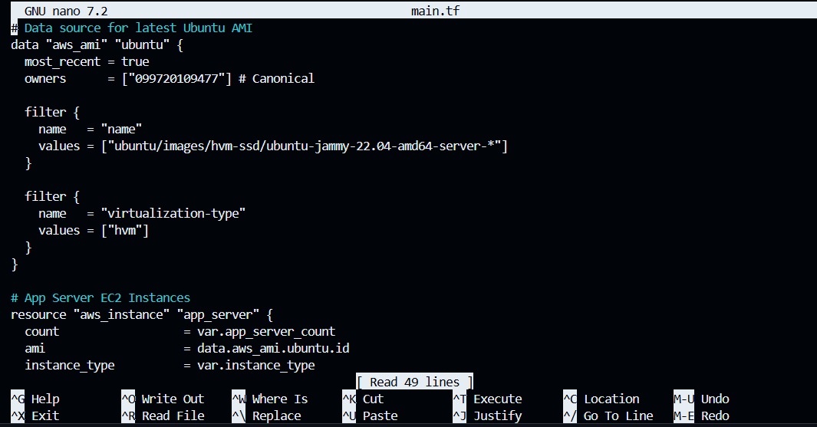
Figure 2.14: Application Servers Module - EC2 Configuration
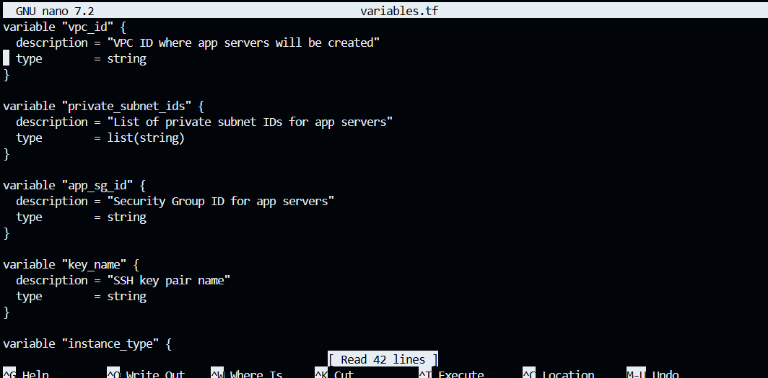
Figure 2.15: Application Servers Module - Variables
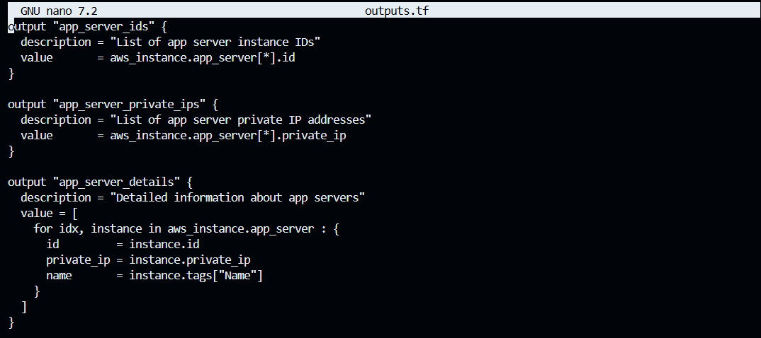
Figure 2.16: Application Servers Module - Outputs

Application Servers Root Configuration
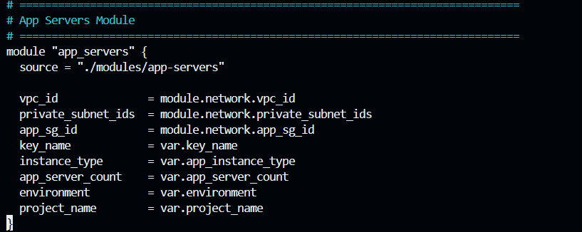
Figure 2.17: Application Servers Root Configuration
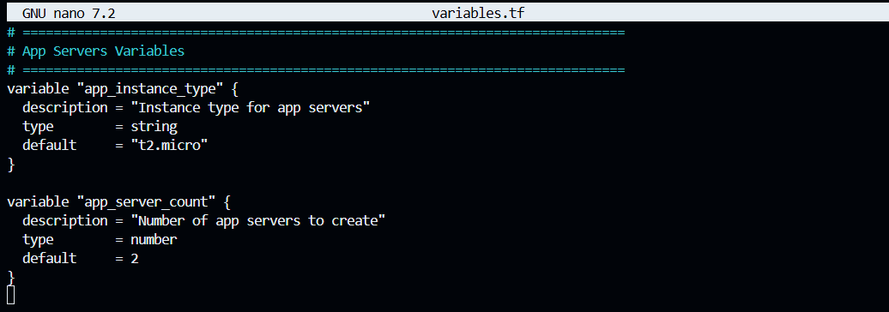Figure 2.18: Application Servers Variables Configuration
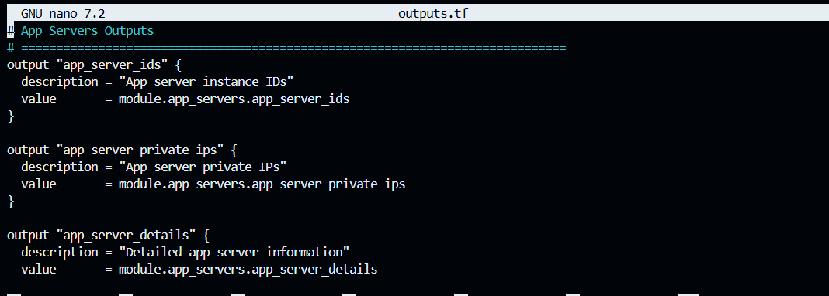Figure 2.19: Application Servers Additional Configuration

Backend Configuration
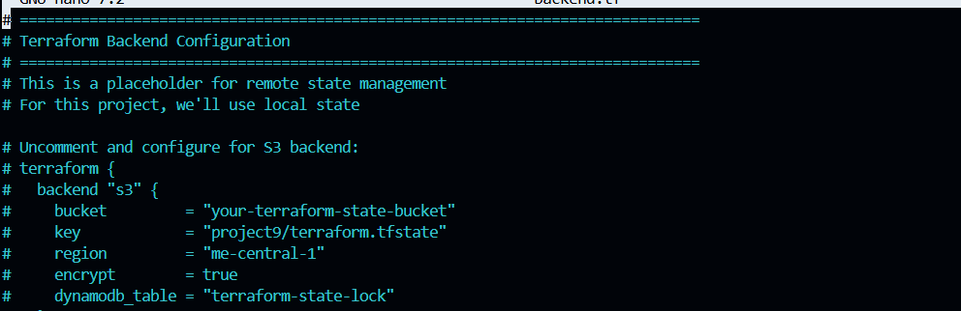Figure 2.20: Terraform Backend Configuration
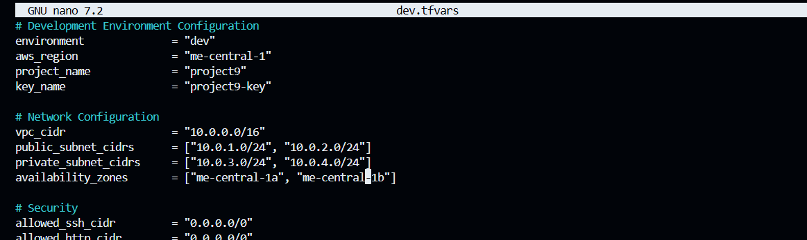Figure 2.21: Backend Configuration-Development
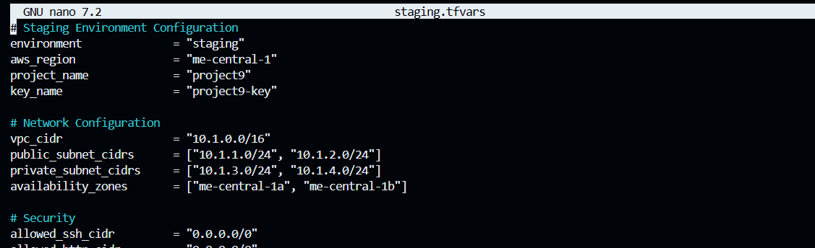Figure 2.22: Backend Configuration-Staging
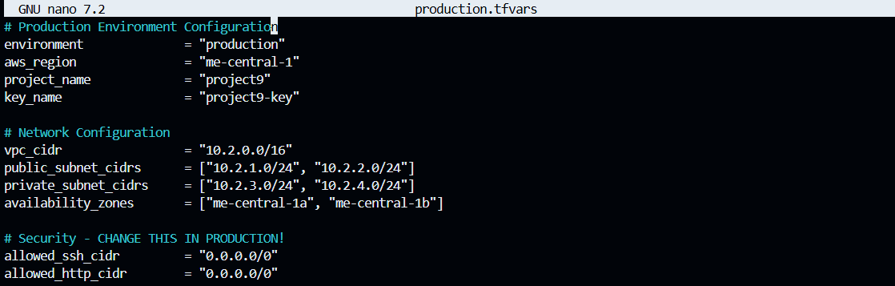
Figure 2.23: Backend Configuration - Complete Setup

Application Servers Deployment
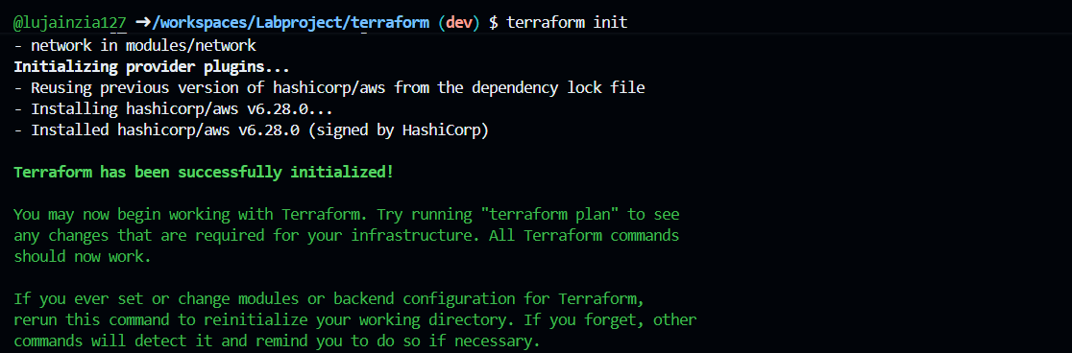
Figure 2.24: Application Servers - Terraform Initialization
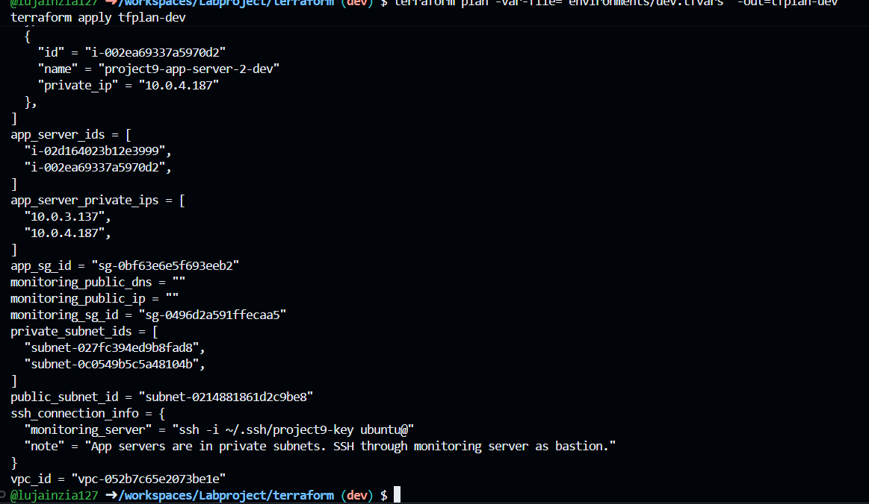
Figure 2.25: Application Servers - Provisioning Success
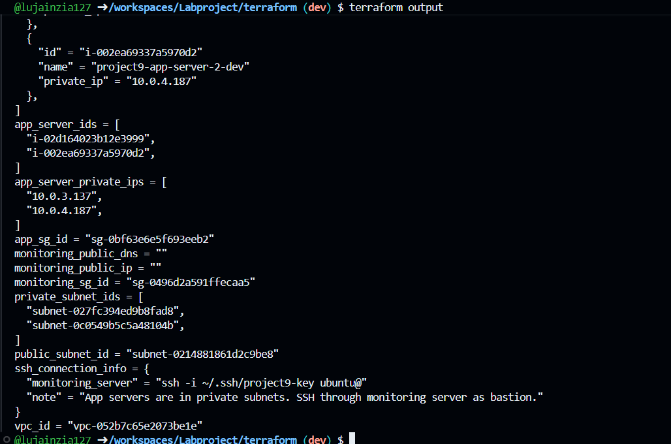
Figure 2.26: Application Servers - Output Showing Private IPs

Part 3: Ansible Configuration

3.1 Configure Application Servers
Ansible roles were created to configure Nginx on all application servers. Each server is configured with a /health endpoint that returns HTTP 200, along with access and error logging.

Nginx App Role Configuration
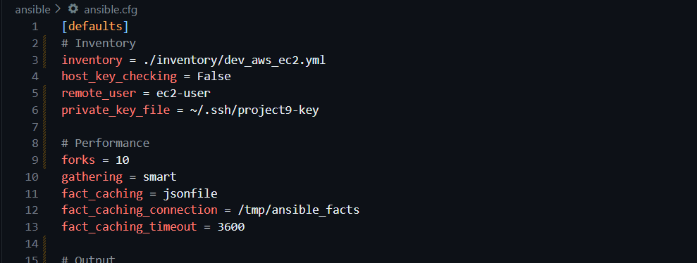
Figure 3.1: Nginx App Role - Installation and Configuration Tasks
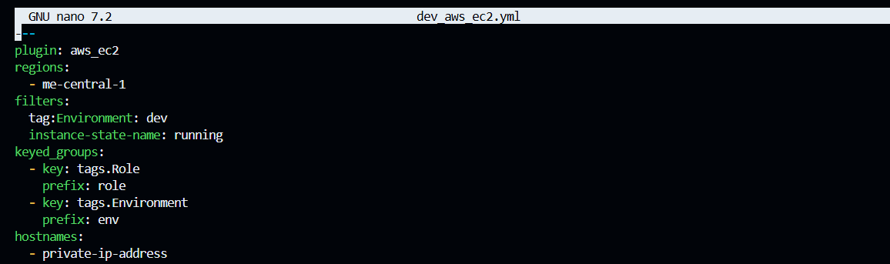
Figure 3.2: Nginx App Role - Service Management Tasks
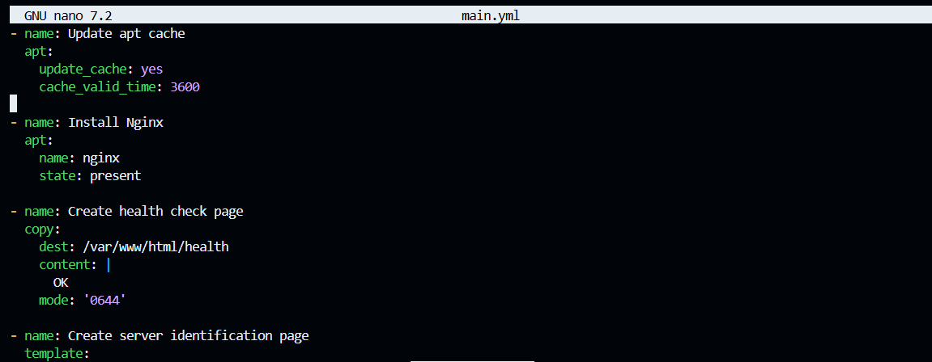
Figure 3.3: Nginx Configuration Template with Health Endpoint
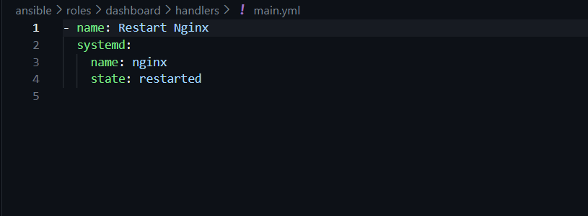
Figure 3.4: Nginx App Role - Handlers for Service Restart
This role installs and configures Nginx on application servers with:
- /health endpoint returning HTTP 200
- Custom index page identifying the server
- Proper logging configuration
- Service management handlers

3.2 Configure Monitoring Server (10 marks)
The monitoring server was configured with multiple monitoring scripts and scheduled cron jobs to automatically collect metrics, check service health, and generate reports.

Dashboard Role Configuration

Figure 3.5: Dashboard Role - Nginx Handlers
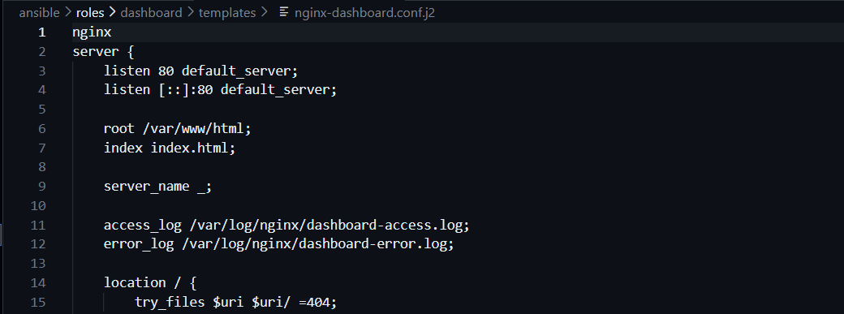
Figure 3.6: Dashboard Nginx Configuration for Serving Dashboard
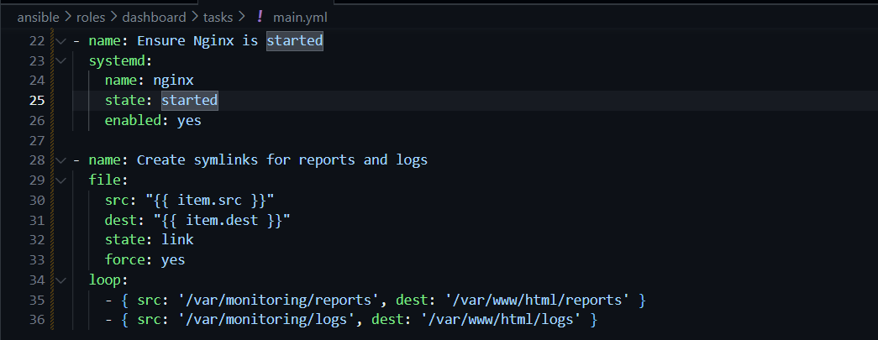
Figure 3.7: Dashboard Role - Setup Tasks

Monitoring Tools Role
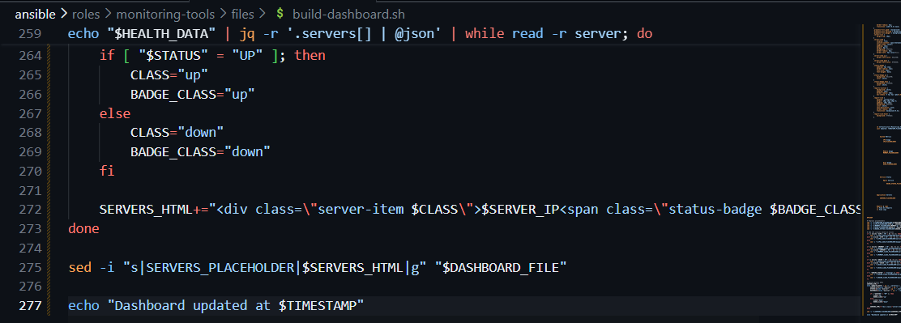
Figure 3.8: Build Dashboard Script - Generates HTML Dashboard
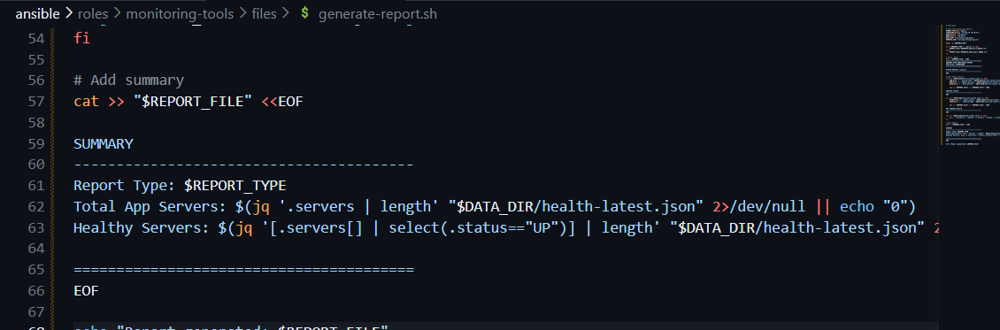
Figure 3.9: Generate Report Script - Creates Daily/Weekly Reports
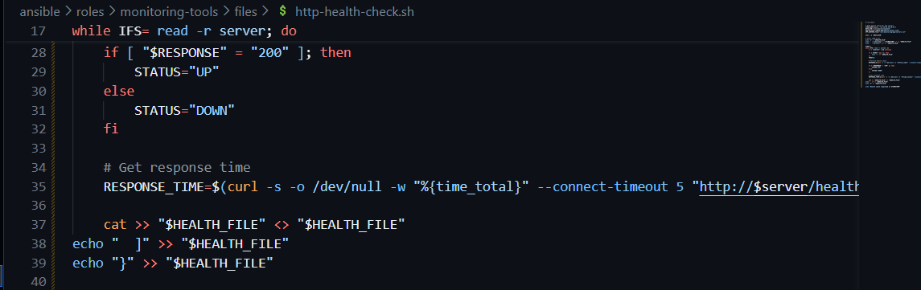
Figure 3.10: HTTP Health Check Script - Checks /health Endpoints
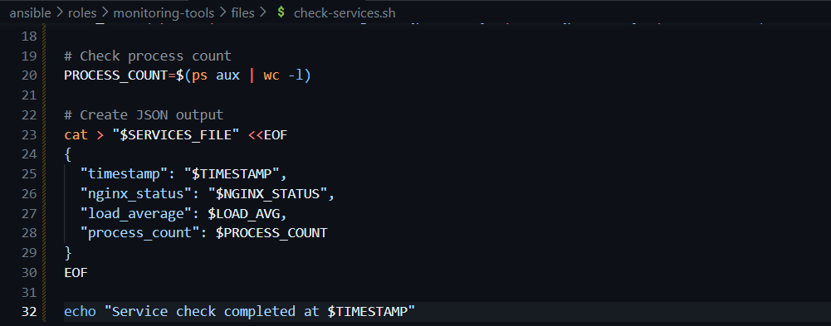
Figure 3.11: Check Services Script - Monitors Service Status
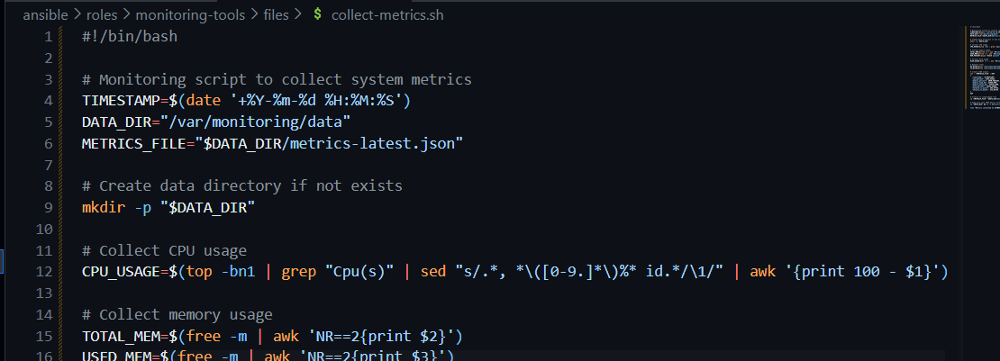
Figure 3.12: Collect Metrics Script - Gathers System Metrics
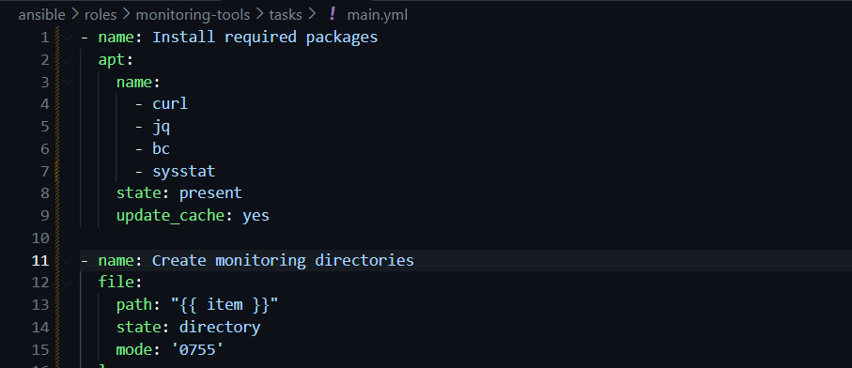
Figure 3.13: Monitoring Tools Role - Installation and Cron Setup
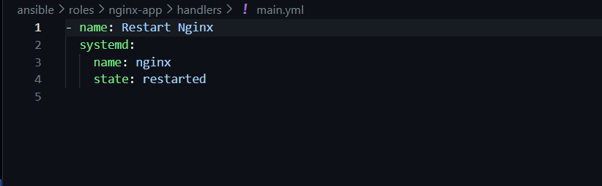
Figure 3.14: Nginx App Role - Handler Configuration
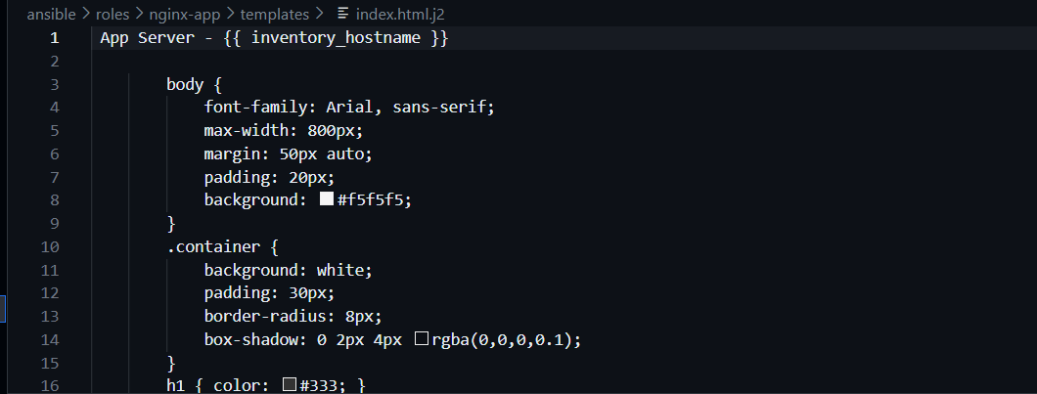
Figure 3.15: Nginx App Role - Index Page Template

Ansible Playbooks
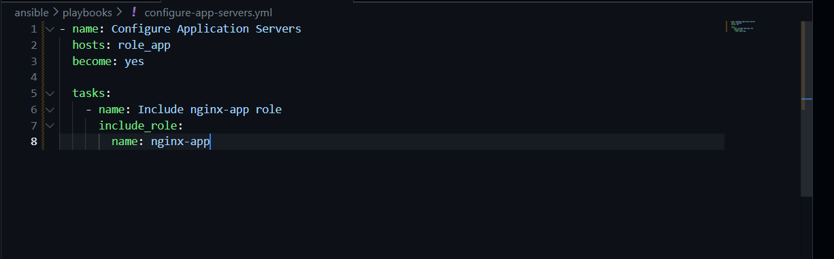
Figure 3.16: Configure App Servers Playbook
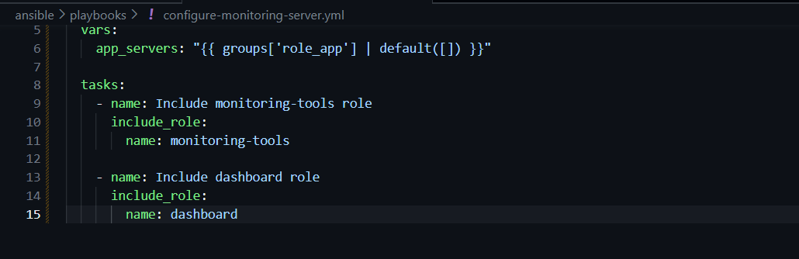
Figure 3.17: Configure Monitoring Server Playbook
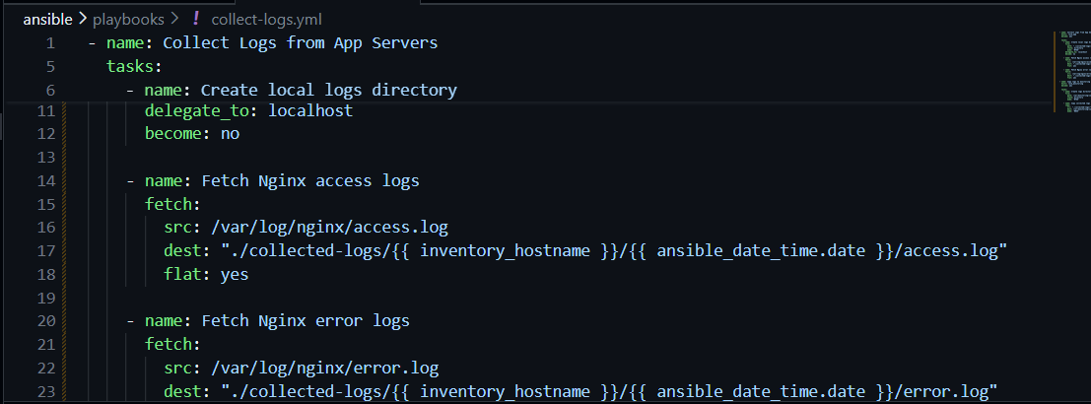
Figure 3.18: Collect Logs Playbook - Uses Ansible Fetch Module
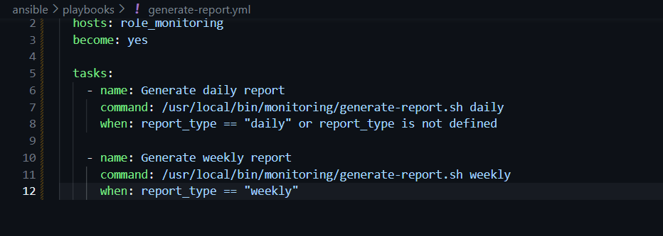
Figure 3.19: Generate Report Playbook - Triggers Report Generation

Playbook Execution and Verification
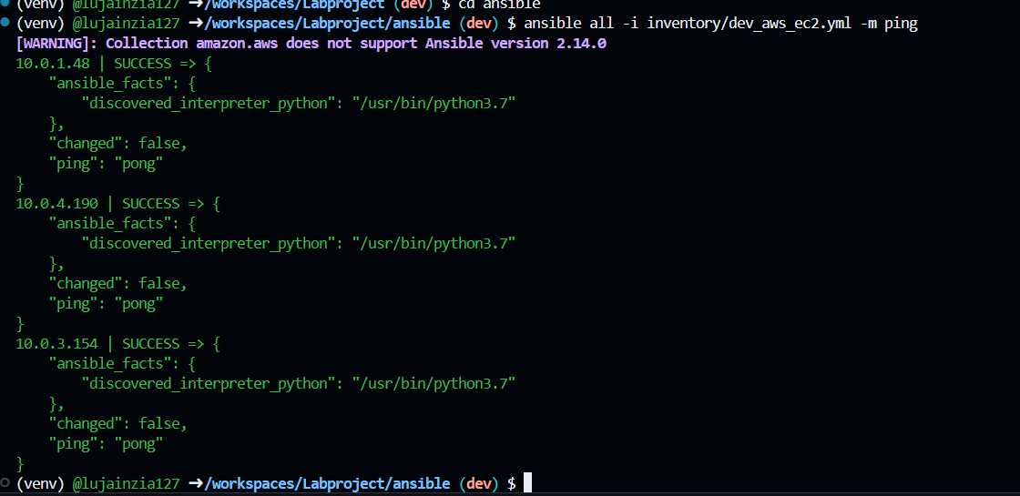
Figure 3.20: Ansible Connectivity Test - All Hosts Reachable
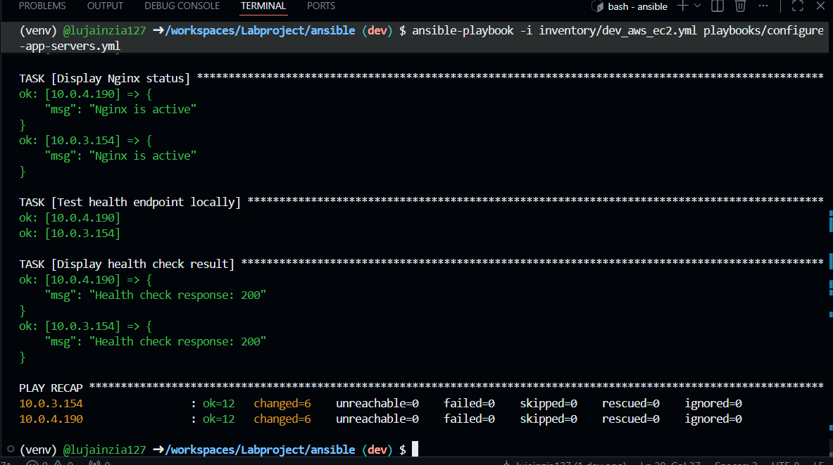
Figure 3.21: Configure App Servers Playbook Execution - Success
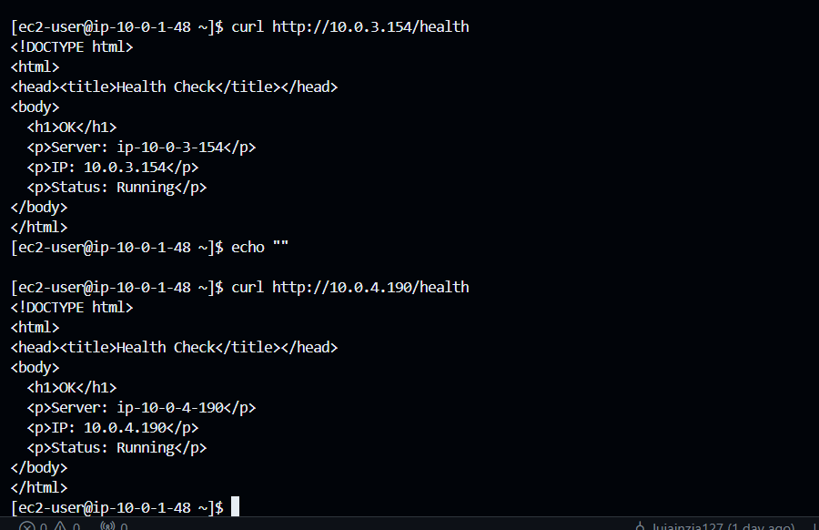
Figure 3.22: Curl Test Showing /health Endpoint Working on All Servers

3.3 Log Collection Using Ansible
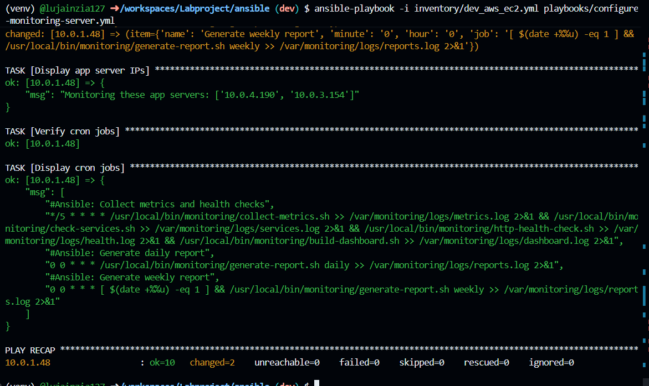
Figure 3.23: Monitoring Server Configuration Playbook Execution
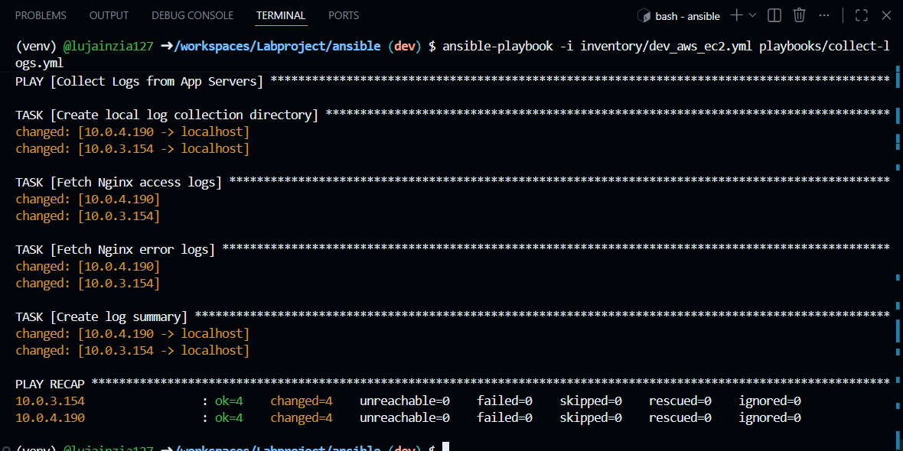
Figure 3.24: Log Collection Playbook - Fetching Logs from App Servers
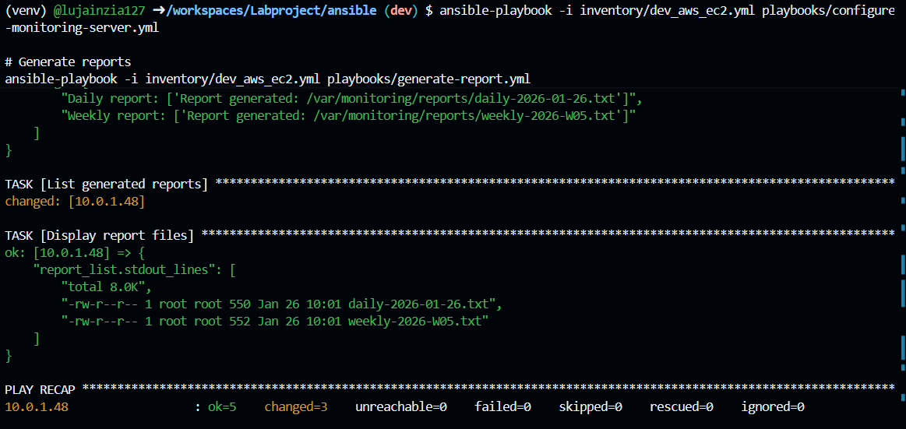
Figure 3.25: Report Generation Playbook - Creating Daily/Weekly Reports

Part 4: Dashboard & Reporting

4.1 Simple Web Dashboard
A web-based dashboard was created to display real-time system status, server health, collected metrics, and links to reports. The dashboard is served by Nginx and updated automatically by the build-dashboard.sh script.
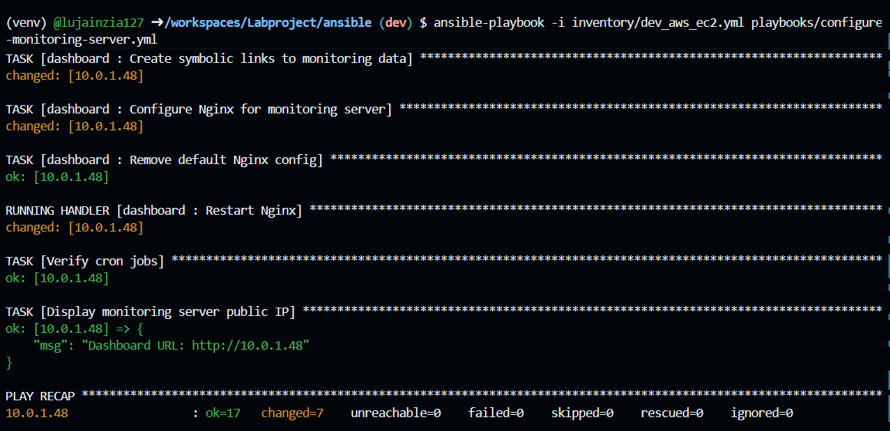
Figure 4.1: Cron Jobs for Automated Monitoring and Dashboard Updates
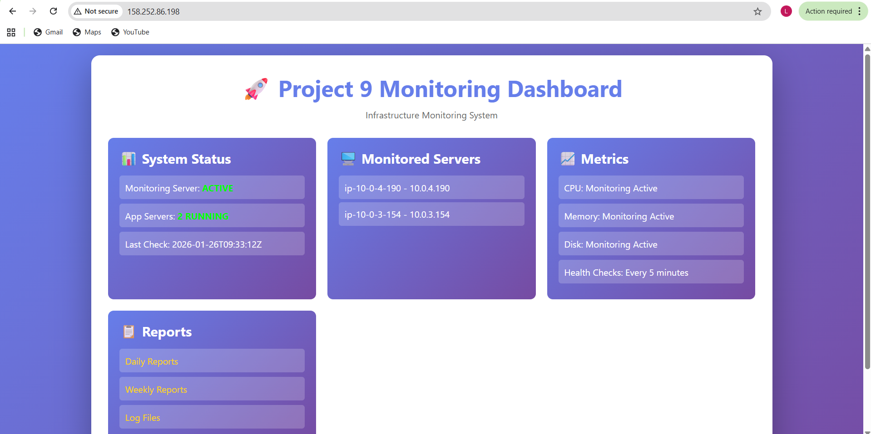
Figure 4.2: Monitoring Dashboard - Header and Server Status
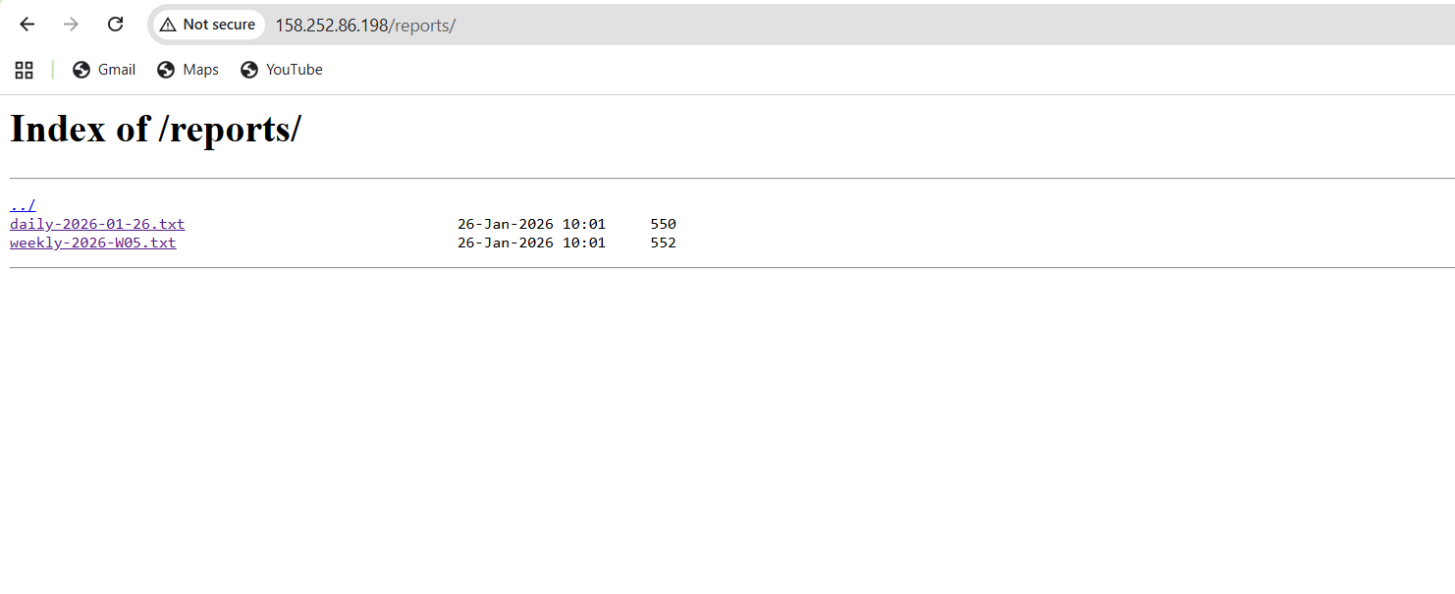
Figure 4.3: Monitoring Dashboard - Links to Weekly and Daily Reports
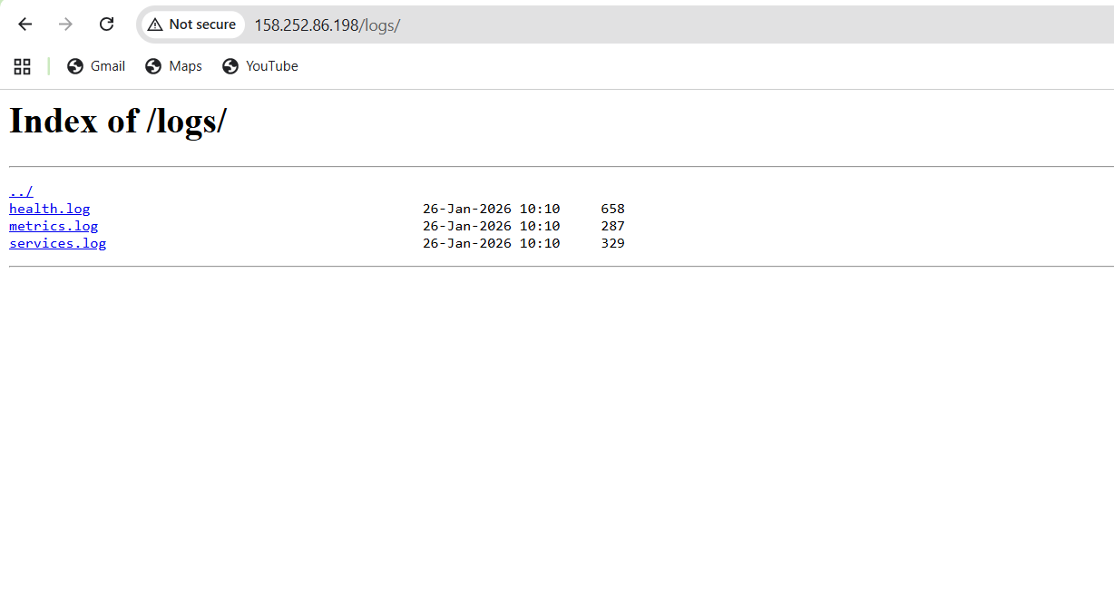Figure 4.4: Dashboard - Links to Iog Files
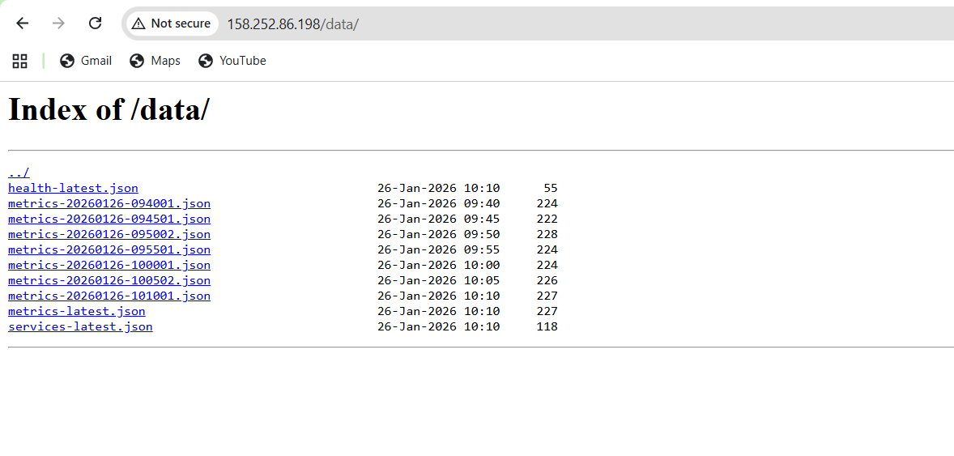
Figure 4.5: Dashboard - Links to Reports and Collected Logs
The dashboard displays:
- Real-time server status (UP/DOWN) for all application servers
- System metrics (CPU, Memory, Disk usage)
- Last health check timestamp

4.2 Automated Reporting (7 marks)
Daily and weekly reports are automatically generated via cron jobs. These reports contain system metrics, health check results, service status, and log summaries. Reports are stored in /var/www/html/reports/ and are accessible through the dashboard.

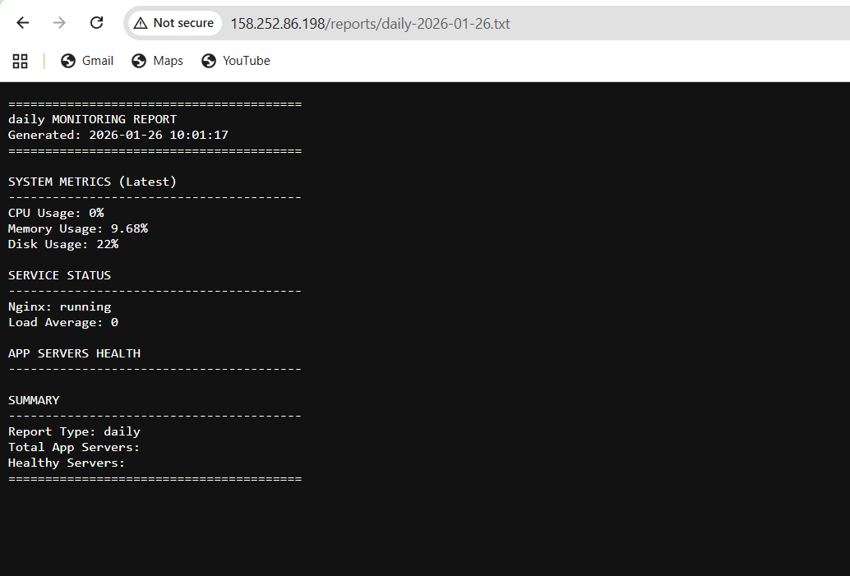
Figure 4.6 :Reort -Daily Monitoring
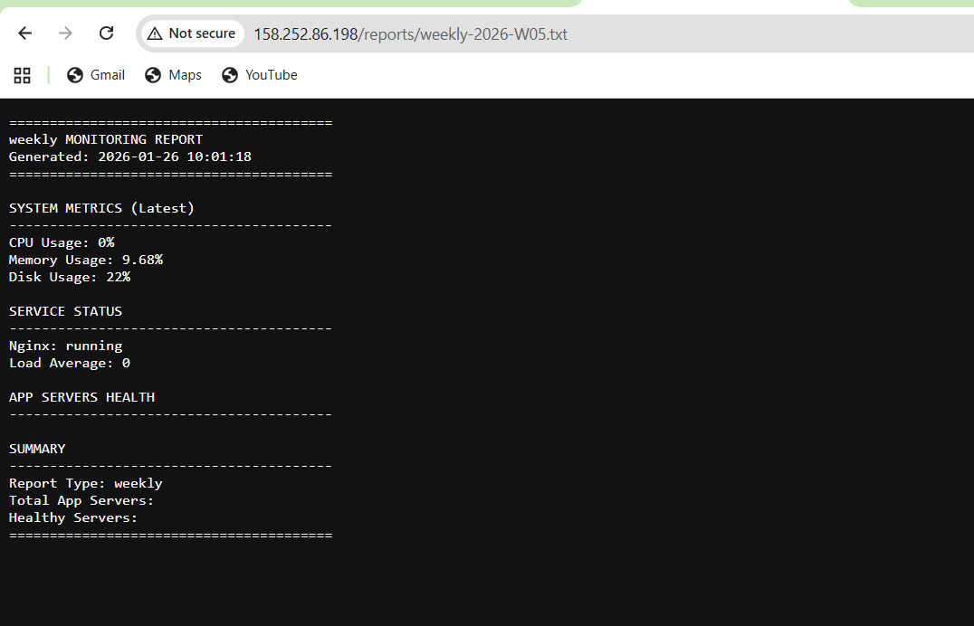
Figure 4.7 : Report -Weekly Monitoring

Merging Branch
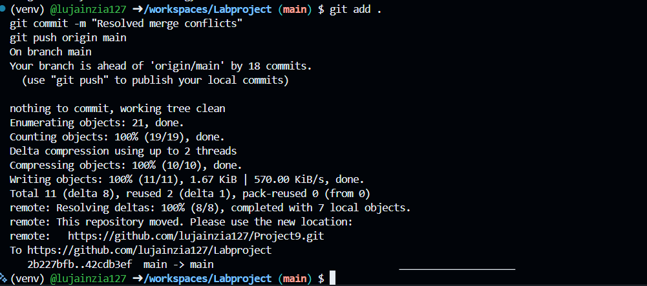
Figure 5 : Git Branch Merge History

Part 5 : Documentation
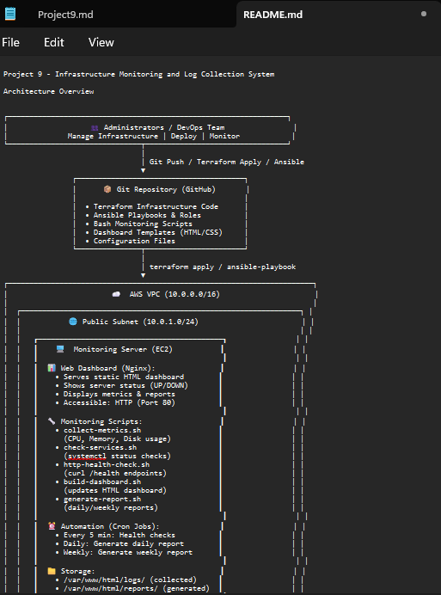
Figure 5.1: README.md - Project Overview and Architecture
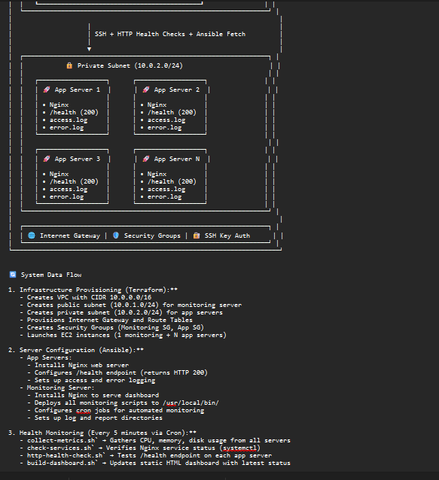
Figure 5.2: README.md - Setup Instructions and Configuration Guide
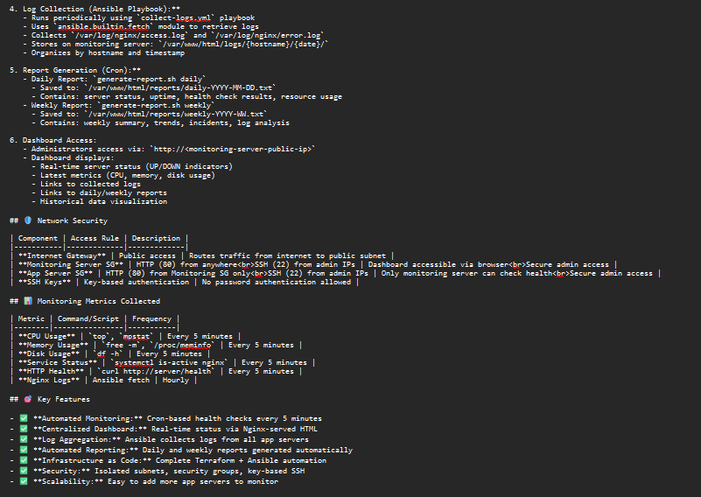
Figure 5.3: README.md - Usage Instructions and Troubleshooting
The README.md includes:
- Project overview and objectives
- System architecture diagram
- Prerequisites and setup instructions
- Terraform provisioning steps
- Ansible configuration procedures
- Dashboard access instructions
- Troubleshooting guide

System Architecture
The system architecture consists of:
- Monitoring Server (Public Subnet)
  - Nginx serving web dashboard
  - Monitoring scripts (bash)
  - Cron jobs for automated checks
  - Log storage from application servers
  - Report generation
- Application Servers (Private Subnet)
  - Nginx web servers
  - /health endpoint for monitoring
  - Access and error logs
  - Sample application
- Network Infrastructure
  - VPC with public and private subnets
  - Security groups for access control
  - Internet Gateway for monitoring server
- Monitoring Flow
  - Daily: Generate daily report
  - Weekly: Generate weekly report

GitHub Repository
Repository Link: https://github.com/lujainzia127/Project9

